# Explore the study area

In this lesson, you'll start a new map in ArcMap and locate your study area of Rondônia, a Brazilian state in the Amazon rainforest. Then, you'll add data layers and visually examine satellite imagery to become familiar with the geography.

## Find the study area

First, you'll start a new map, become familiar with ArcMap's user interface, and find the project's study area.

1. Start ArcMap.

The **ArcMap - Getting Started** window opens. This window allows you to open previously used files, which don’t need now.

Close the **ArcMap – Getting Started** window.

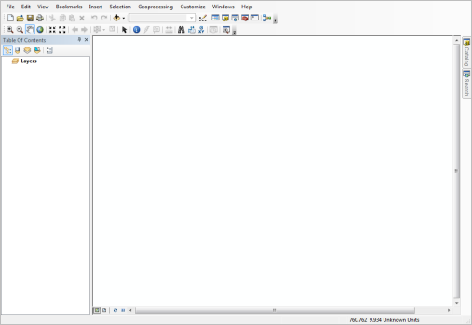

A blank map opens. Above the map are toolbars. By default, the Standard and Tools toolbars are turned on. To the left of the map is the Table Of Contents, which shows the geographic content of your map. Like the map, the Table Of Contents is empty.

Note:

If you've used ArcMap before, your interface may be arranged differently.

Next, you need to download the data for this lab exercise from <https://github.com/qiang-yi/NUAA>

Unzip the downloaded data in a folder in your computer (for example, under the E drive).

1. On the **Standard** toolbar, click the **Add Data** button.

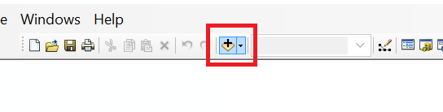

1. If you can’t find the folder where you stored the data in the **Look in** list, you need to connect to that folder first, by clicking **Connect to folder,** and then browse to the folder, select the folder and click **OK**.

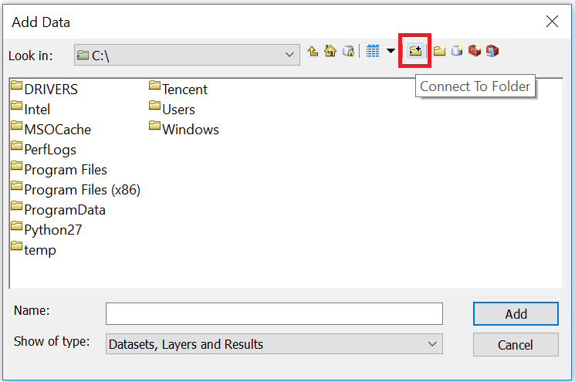

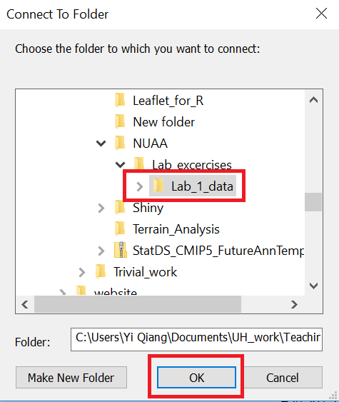

1. Then you can find the connected folder in the **Look in** list. Browse to that folder, select Amazon_Ecoregion.shp, Brazilian_States.shp, and Cities.shp, click **Add** to add these data into ArcGIS.

Note:

.shp files are shapefile, which is the most common vector data format in GIS. Every shapefile has multiple elements (.cpg, dbf, prj, shp, shx...) which stores the geometries of the vector objects (points, lines or polygons), attribute table, projection information, and meta data. But in ArcGIS, you only see one file. For more information about shapefile, please read [this](http://doc.arcgis.com/en/arcgis-online/reference/shapefiles.htm).

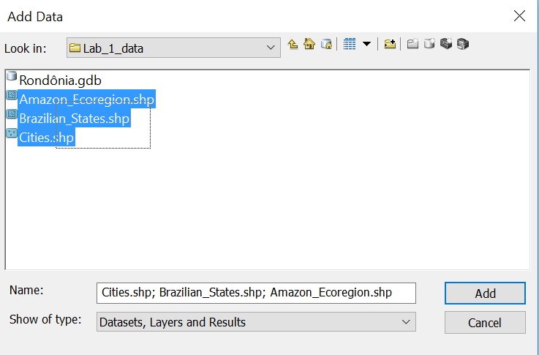

The layers appear on the map as a large orange shape. These are the boundaries of the Amazon ecoregion, Brazilian state boundaries, and Brazilian cities. But it's not clear where in the world the boundaries are located. Next, you'll add a basemap. A basemap depicts background reference information such as landforms and political boundaries. It can help show your data's location in the context of the world.

1. On the **Standard** toolbar, click the arrow next to the **Add Data** button and choose **Add Basemap** (see below).

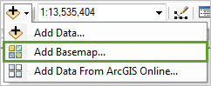

1. In the **Add Basemap** dialog box, click **Imagery (影像图)** and click **Add**. Close the **Geographic Coordinate Systems** warning.

Note:

If the **Hardware Acceleration** dialog box opens, click **Yes**. This will allow your basemap to draw faster.

The Imagery basemap is added to the map and the Table Of Contents under the Amazon Ecoregion layer. It uses satellite imagery as reference information.

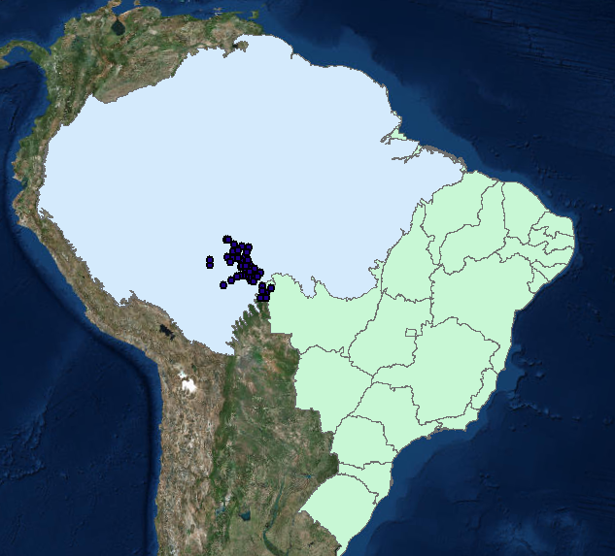

The **Table of content** list all data layers that are added in ArcGIS. You can change the order of the layers by dragging the data layers in the **Table of content**, for instance, you can drag the **Cities** layer to the top of the list. You can check the layer to make it visible, and uncheck to make it invisible.

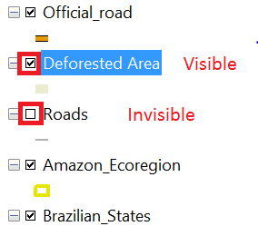

1. By clicking the symbols of the Amazon_Ecoregion layer in **Table of Content**, you can open a dialog to change the properties of the symbols (points, lines and polygons). In this dialog, change the **Fill Color** as no color, **Outline Width** as 2, **Outline Color** as some random color. Then, only the boundary of the Amazon Ecoregion is showing in the map.

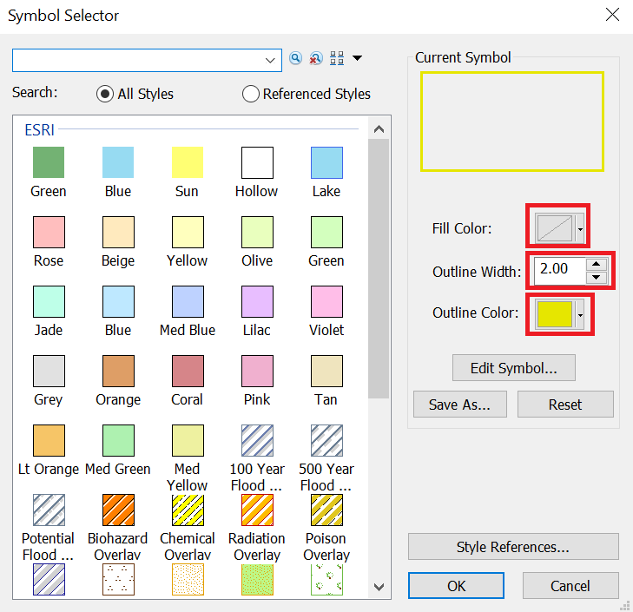

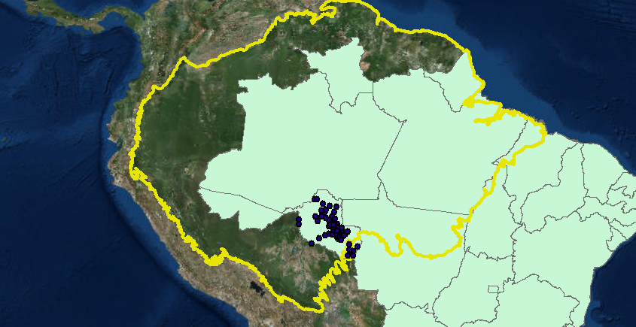

The layer appears on top of the Amazon Ecoregion layer. However, some of the layer extends beyond the current map extent, or zoom level. To see the whole layer, you'll zoom out.

1. In the panel of ArcGIS, you can navigate the map using Zoom in, Zoom out, Pan, and full extent bottom.

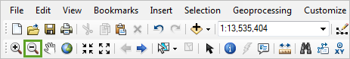

When you move the pointer over the map, it becomes a magnifying glass.

1. Click anywhere on the map. Click the map again.

The map zooms out and centers on the location you clicked. You're zoomed out far enough to see the entire layer, but the layer may not be centered in the map frame.

Tip:

You can also zoom using the mouse's scroll wheel. Depending on your screen resolution and monitor size, you may need to zoom more to see the entire layer.

1. On the **Tools** toolbar, click the **Pan** tool.

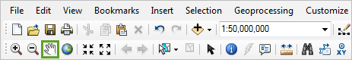

When you move the pointer over the map, it becomes a hand.

1. Drag the map until the Brazilian States layer is in the center.

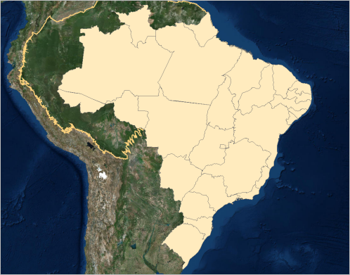

Unlike the Amazon Ecoregion layer, which has only one feature, the Brazilian States layer has twenty-seven features. Features are discrete representations of a real-world object on a map. In this instance, each state is a feature. Features also contain attribute data, which describes the feature's characteristics.

1. On the **Tools** toolbar, click the **Identify** tool.

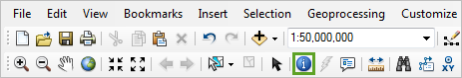

1. Click any state on the map.

The state flashes green and the Identify dialog box opens.

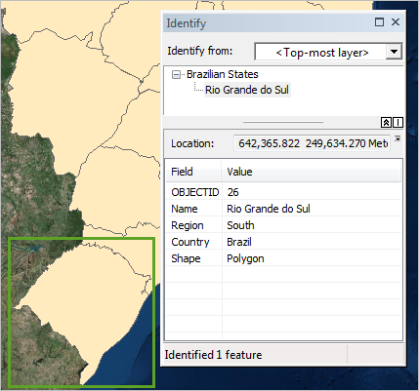

The Identify dialog box shows the attribute data, or information, for the feature you clicked. Although you can identify states until you find Rondônia (if you were lucky, it may have been the state you clicked), you can use a quicker method to find a feature with a specific attribute.

1. Close the **Identify** dialog box.

## Organize and symbolize the data

Currently, you can't see the basemap under the Brazilian States layer. You'll change the layer's symbology to better see your layers. You'll also organize the layers in the Table Of Contents.

1. In the **Table Of Contents**, click the symbol for the **Brazilian States** layer.

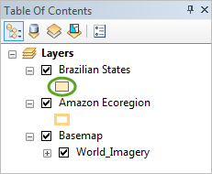

1. For **Fill Color**, choose **No Color**.

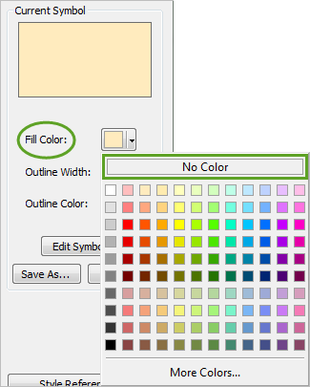

1. For **Outline Width**, highlight the existing value of **0.40** and type 1.50.
2. For **Outline Color**, choose **Arctic White**.

Tip:

On the color palette, you can see the name of a color by pointing to it.

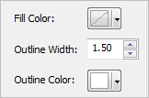

1. Click **OK**.

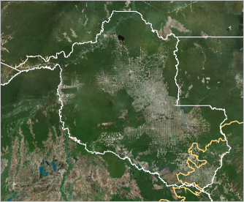

The symbology changes. The Brazilian States layer now has only a white outline.

The Amazon Ecoregion layer (the orange line) is beneath the Brazilian States layer (the white lines). Layers are drawn on the map in their order in the Table Of Contents.

1. In the **Table Of Contents**, drag the **Amazon Ecoregion** layer above the **Brazilian States** layer.

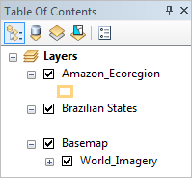

The Amazon Ecoregion layer appears above the Brazilian States layer.

1. Examine the map.

When the map was zoomed to South America, the area inside the Amazon Ecoregion layer appeared greener than the area outside. In Rondônia, however, a large portion of the land is grayish-brown terrain, with the green regions mostly in the northern and western parts of the state. The large, barren-looking area is deforested.

Although the land looks barren, it is actually not. While deforestation in the Amazon does occur for extractive purposes, such as acquiring lumber, a lot of deforestation clears land for cattle grazing or perennial agriculture. Most of the seemingly barren terrain is actually pasture or farmland.

The soil quality in the region is poor and quickly depleted of nutrients. As such, it is difficult to regrow Amazon rainforest after it has been deforested. To protect the rainforest, prevention of future deforestation is the key.

## Add and symbolize the Cities layer

You've found your study area. Now, you'll symbolize the **Cities** layer to show the largest cities by population in the province of Rondônia.

1. Right click on the **Cities** layer, click **Zoom To Layer**, and then you will zoom into the cities in Rondônia.

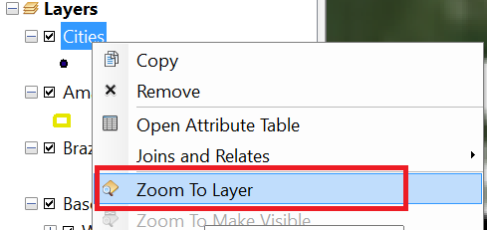

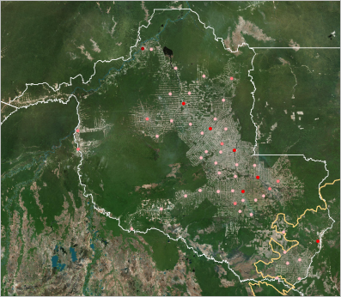

1. In the **Table Of Contents**, right-click the **Cities** layer and choose **Open Attribute Table**.

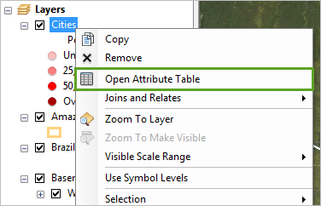

In the Attribute Table, attributes are organized into columns, or fields, and features are organized into rows.

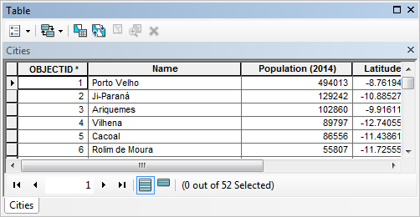

The fields give the name of each city, its 2014 population, its latitude, and its longitude. The OBJECTID and Shape fields are managed by the software. The populations of the 52 cities in Rondônia range between 2,000 and 500,000.

1. Close the table.

Next, we will symbolize the cities by size, with larger symbols indicating larger populations.

1. In the **Table Of Contents**, right-click the **Cities** layer and choose **Properties**.

The Layer Properties dialog box opens. This dialog box includes more symbology options than the Symbol Selector you used earlier.

1. At the top of the **Layer Properties** dialog box, click the **Symbology** tab. The symbols are set by **Quantities**, which classifies attribute values into ranges and gives each range a unique symbol. Under **Quantities**, we choose **Graduated symbols** to symbolize the cities by size. In the **Value** list, you can choose the attribute of the data layer to be symbolized. Here, we choose Population.

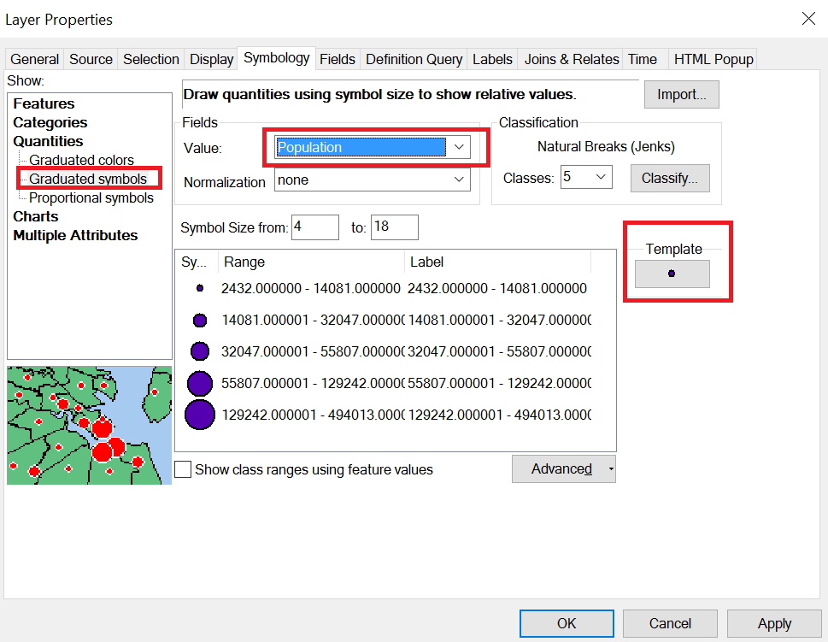

1. Click the **Template** button, and change the color of the symbols into **Arctic White**.

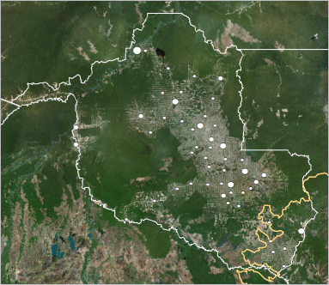

On the map, the largest cities tend to be in the middle of the deforested area, although they range in distribution from north to south. Smaller cities tend to be closer to the edge of the deforestation.

## Add and symbolize the Roads layer

You've added reference data to your map. Next, you'll add data to be used in your analysis of the relationship between roads and deforestation. In ArcMap, to the right of the map, click the **Catalog** tab. Find the **Rondônia.gdb** in the folder where you store the exercise data.

1. Click the **plus sign** next to the folder connection to expand it. Then, expand **Rondônia.gdb**.

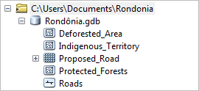

Note:

The extension .gdb stands for geodatabase. In the Catalog, geodatabases have a gray cylinder icon.

The geodatabase contains four feature classes and one raster dataset, which can be added to the map as layers. You'll learn more about raster datasets later. Feature classes are groups of features sharing similar attributes and geometry, like the Brazilian States layer. The term layer refers to a map representation of data, while feature class refers to the file-based data itself. Feature classes come in three main types: point, line, and polygon.

Before you add the data to your map, you'll set the Rondônia geodatabase as the default geodatabase for your map document. The default geodatabase is the location where new datasets are saved by default.

1. In the **Catalog** window, right-click **Rondônia.gdb** and choose **Make Default Geodatabase**.

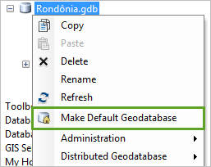

Next, you'll add a layer of roads. There are two main types of roads in Rondônia: Official roads, built by or with the permission of the government, and unofficial roads, built independently of the government. Because your ultimate goal is to determine the potential deforestation caused by a proposed road, looking at existing roads is vital to your final analysis.

1. In the **Catalog** window, drag the **Roads** feature class to the **Table Of Contents**, below the **Brazilian States** layer.

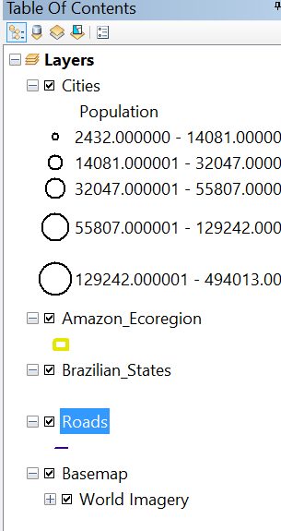 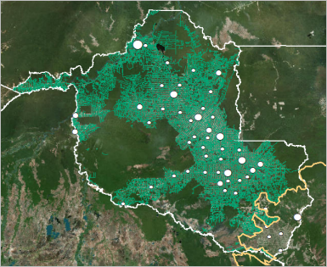

Note:

When you add a layer from your computer it has random default symbology. Your symbology may be different from the example images.

The Roads layer contains a dense network of roads that covers most of the state. The layer doesn't extend past the Amazon Ecoregion boundary.

1. In the **Table Of Contents**, right-click the **Roads** layer and choose **Open Attribute Table**.

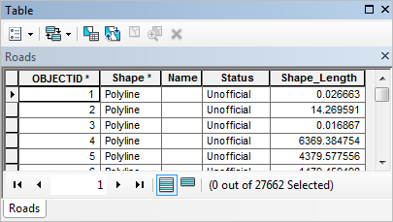

Among the fields are Name and Status. Status shows whether a road is official or unofficial. Unofficial roads do not have names, although official roads might. The number at the bottom of the table reports the total number of features: 27,662. Which roads on the map are official and which are unofficial? You could use graduated symbology options to give each type of a road a unique appearance, or you could use an attribute query to select all features in a layer with a certain attribute.

1. On the ArcMap main menu, click **Selection** and choose **Select By Attributes**.

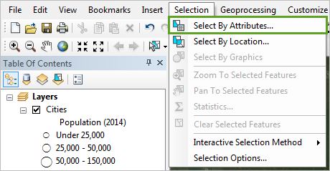

The Select By Attributes dialog box opens. It has many options and can look complicated at first. You'll become familiar with its interface before you use it.

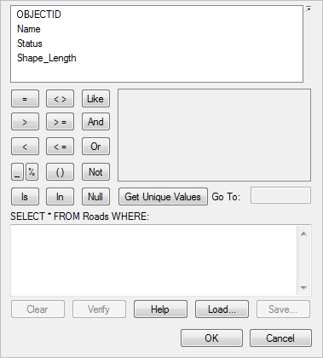

In this dialog box, you build a logical expression to determine the attribute by which features will be selected. In the topmost box are the field names in the selected layer. Below it are the logical operators, which define the relationship between two things. To the right of the logical operators is a box that displays the unique values of a field you select, and the bottom box contains the expression.

Using these options, you'll create an expression to find roads where Status = Official.

1. For **Layer**, choose **Roads** from the list.

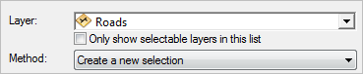

1. In the list of fields, double-click **Status**.

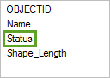

The word Status appears in the box at the bottom of the dialog box.

1. In the list of logical operators, click the **equal sign** (=) button.

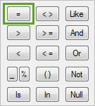

An equal sign appears next to the word Status. Next, you'll add the unique value of Official.

1. Next to the list of logical operators, click **Get Unique Values**. Double-click **'Official'** to add it to the query.

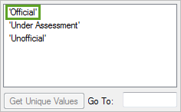

The word Official in single quotation marks appears in the box at the bottom. Your query should look like the following image:

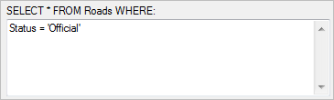

1. At the bottom of the **Select By Attributes** dialog box, click **OK**.

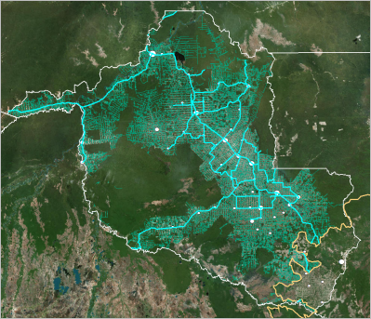

Official roads are selected (highlighted in blue) on the map.

Official roads appear to connect municipalities and facilitate travel between population centers. Although they mostly appear in deforested areas, deforestation does not solely occur in places where there are official roads. There appear to be significantly fewer official roads than unofficial roads.

The ability to see official roads independent of the total road network is useful reference information. However, a selection is not permanent and will be erased if you make another selection or deselect the features. To prevent this, you'll export the selected road into a new shapefile.

1. In the **Table Of Contents**, right-click the **Roads** layer, point to **Selection**, and choose **Create Layer From Selected Features**.

The Roads selection layer is created and added to the top of the Table Of Contents.

1. On the **Tools** toolbar, click the **Clear Selected Features** button.

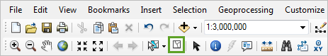

The original selection is cleared. It may have the same symbology as the original Roads layer, so you may not be able to see it in the map.

1. In the **Table of Contents**, click the symbol for the **Roads selection** layer to open the **Symbol Selector**. Scroll through the preset symbols and click the **Stacked Multi Roadway** symbol.

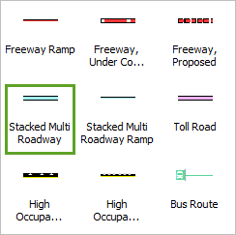

1. Change the color to **Seville Orange**.

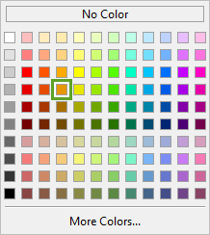

1. Click **OK**.

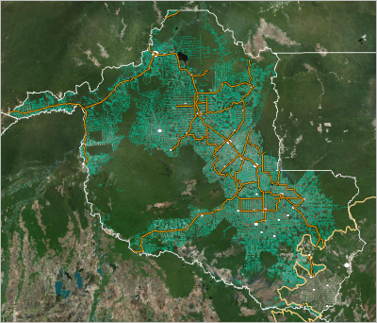

The official roads cover up the cities. Also, the Roads selection layer should be renamed to better reflect what it shows.

1. In the **Table of Contents**, click the name of the **Roads selection** layer to edit it. Change the name to Official Roads.

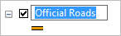

1. Drag the **Roads selection** layer below the **Brazilian States** layer and above the original **Roads** layer.

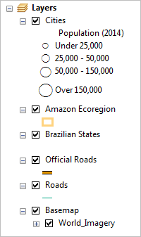

Lastly, you'll change the symbology of the original Roads layer.

1. In the **Table Of Contents**, click the symbol for the **Roads** layer to open the **Symbol Selector**. In the list of symbols, click the **Arterial Street** symbol.

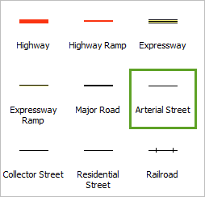

1. Change the color to **Raw Umber**.

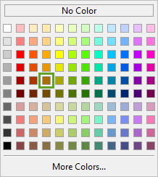

1. Click **OK**.

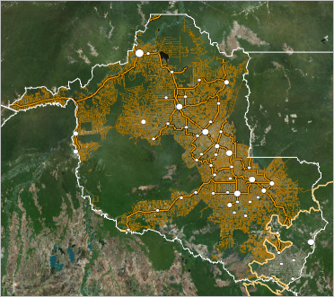

The difference between official and unofficial roads is clear. Unfortunately, the unofficial roads still clutter the map. Because the official and unofficial roads are now in separate layers, you can turn off the Roads layer to temporarily hide it while keeping the Official Roads layer visible.

1. In the **Table Of Contents**, uncheck the box next to the **Roads** layer.

You can turn the layer back on at any time by checking the box again. For now, you'll leave it off.

## Select by location

In the previous section, you’ve practiced to select features by their attributes (i.e. population). In this section, we will use **Select by Location** to do spatial queries. We will select states that are within (contained by) the Amazon Ecoregion. As you’ve learned in the class, the spatial queries are based on topological relations encoded in GIS data.

1. We zoom out the map so that we can see the whole area of Amazon Ecoregion.

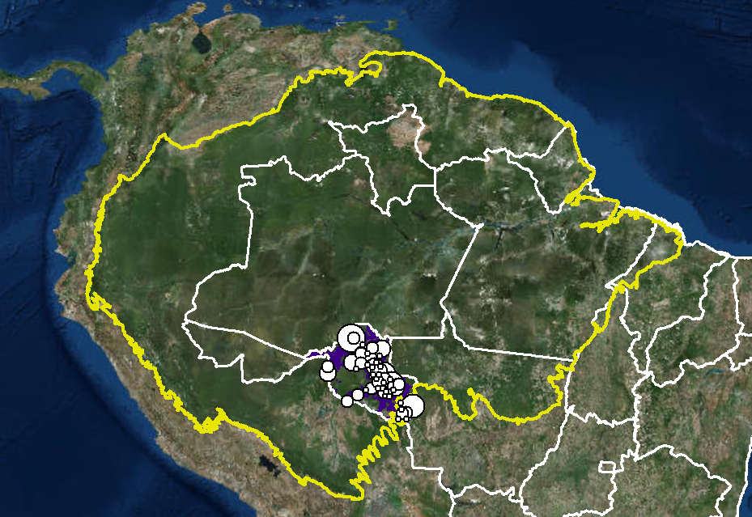

1. In ArcGIS panel, we click the **Selection** menu, and then click **Select by Attribute.**

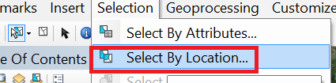

1. In the selection dialogue, you can choose the Brazilian States as the **Target Layer**. This means that you will select features from the Brazilian States.
2. Then, choose the Amazon Ecoregion as the **Source Layer.** The source layer defines your selection criterion.
3. In **Spatial selection methods for the target layer feature(s)**, choose “are within the source feature layer”. This means you will select Brazilian States that are within the Amazon Ecoregion.

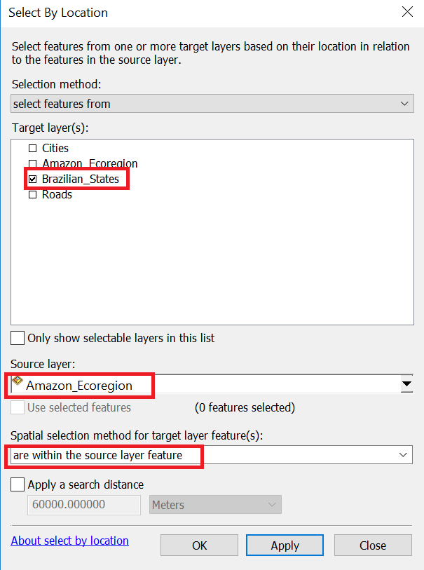

1. States that are within Amazon Ecoregion are selected in the map (highlighted with green boundaries). This is a typical spatial query based on topological relations between the features. You can try the different selection methods to see their difference.

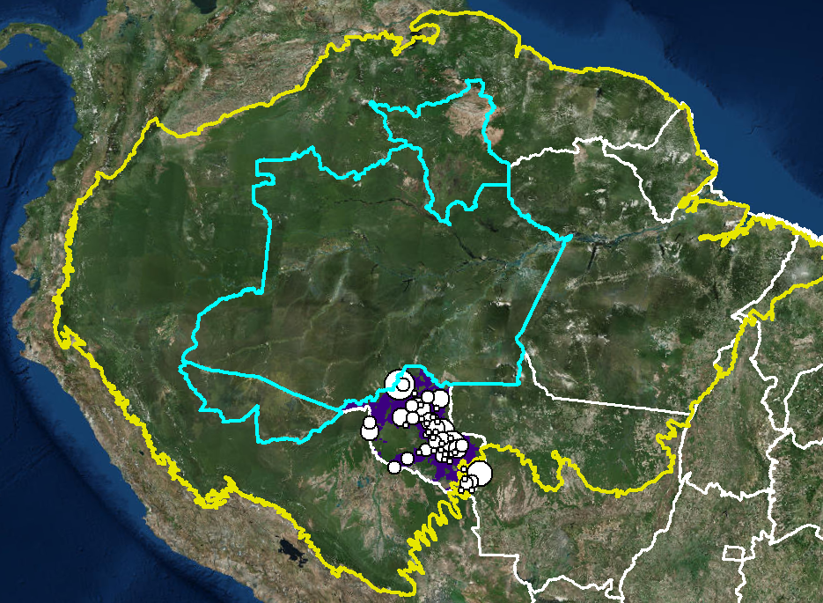

1. You can use **Clear selected feature** to unselect the features.

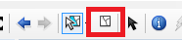

## Save the map

Next, you'll save your map so you can return to it at any time. The saved map is .mxd linked to the downloaded GIS data. In default, the .mxd file is linked to the absolute path of the GIS data in your computer, which will not work if the file and data are copy to another path or another computer. So, it would be better to change the linkage into relative path.

1. Click the **File** menu, and click **Map Document Properties**. Then check “Store relative pathname to data sources”. Doing this will make the map linked to only relative path of data. Next, we can save the project file.

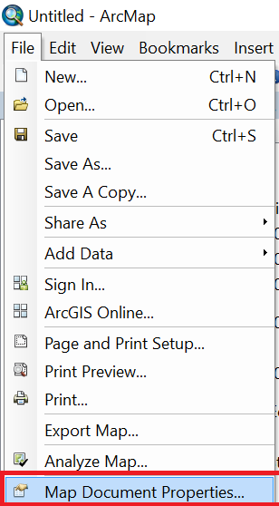 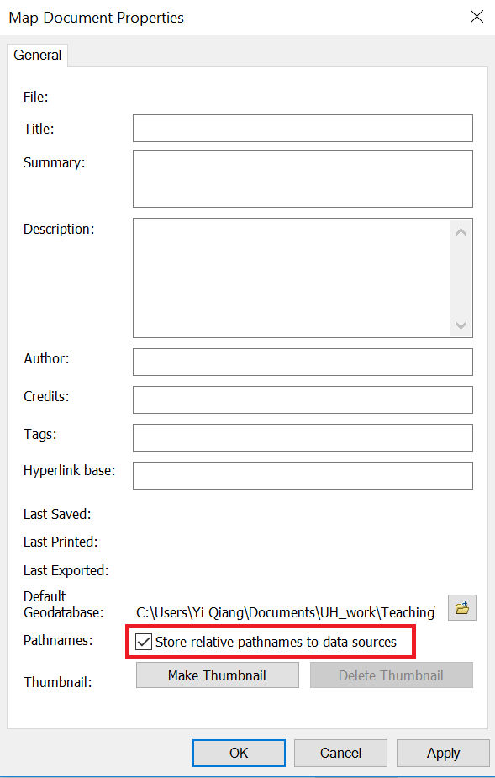

1. On the **Standard** toolbar, click the **Save** button.

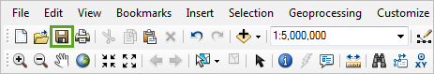

The Save As dialog box opens.

1. Name the map Amazon Deforestation and save it in the folder of the downloaded data.

The map document is saved with the extension .mxd, which is the standard extension for ArcMap map documents. If you copy the folder to another path or another computer, you can still open the map file that is correctly linked to the data you’ve added.

# Compare roads and deforestation

In the previous lesson, you familiarized yourself with the study area and visually analyzed the deforestation you could see from the Imagery basemap. In this lesson, you'll take your analysis a step farther. First, you'll add a layer showing the extent of deforestation. Then, you'll quantify the percentage of land that is deforested within a certain distance from roads. By finding the relationship between existing roads and deforestation, you'll later be able to estimate the deforestation prevented by the proposed road's prohibition.

## Explore deforestation

Although you looked at deforestation in the last lesson, now you'll begin a more thorough exploration in order to understand existing deforestation patterns in Rondônia. You'll start by adding a layer that shows deforestation in the state.

1. Open your Amazon Deforestation map document in ArcMap.
2. In the **Catalog** window, drag the **Deforested_Area** layer to the **Table of Contents**, below the **Roads** layer. After adding the layer, you can right click the layer in **Table of Contents**, and then click **Zoom to the layer** to zoom in.

Tip:

In ArcGIS, there are two ways to add data. You can either use the **Add Data** button to add data (you’ve done that in the beginning), or drag the data from **Catalog** into ArcGIS.

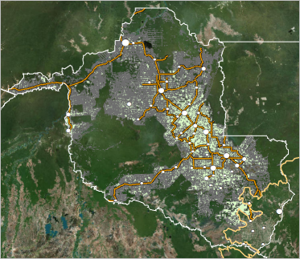

1. In the **Table Of Contents**, click the symbol for the **Deforested Area** layer. In the **Symbol Selector**, change the symbol's **Fill Color** to **Lime Dust**.

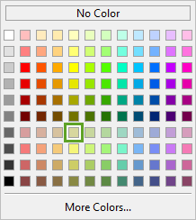

1. Change the **Outline Color** to **No Color**.

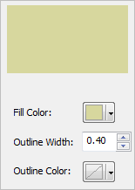

1. Click **OK**.

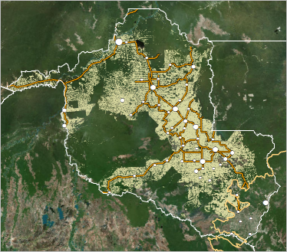

If you open the **Attribute table** of **Deforested area**, you will see there is only one record in the table. This means that the layer has only one feature. This is a multipart feature: a feature composed of many noncontiguous elements. Deforestation typically occurs in small parcels, not large unbroken swaths. At this map scale, it's difficult to see deforestation in much detail. You'll zoom in to look closer, but first you'll bookmark the current map extent. With a bookmark, you can quickly navigate to specific map extents.

1. On the ArcMap main menu, click **Bookmarks** and choose **Create Bookmark**.

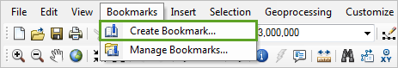

The Create Bookmark dialog box opens.

1. Change the bookmark name to Rondonia and click **OK**.

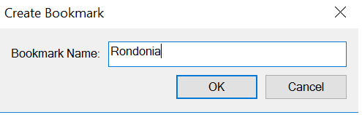

Bookmark is a saved zoom-in level. You can easily return to the zoom-in level by clicking the bookmark.

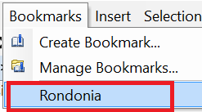

1. On the **Tools** toolbar, click the **Zoom In** tool.

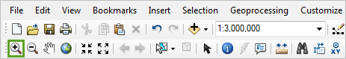

When you move the pointer over the map, it becomes a magnifying glass.

1. Draw a rectangle around the area of deforestation in northwestern Rondônia.

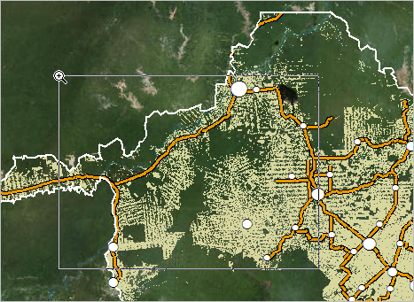

The map zooms to the extent of the rectangle. Once zoomed in, you can see the deforestation in more detail. Deforestation is often patchy, like in the following image:

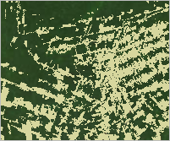

Typically, small strips of forest are deforested through a process called slash-and-burn agriculture. In slash-and-burn-agriculture, small farmers cut and burn plots of forest to create fields. The burned biomass serves as fertilizer for agriculture on the cleared land. This agricultural technique has been practiced for centuries throughout the world, including the Amazon. In small amount, slash-and-burn agriculture can be sustainable. But when widespread, massive areas are cleared in a small amount of time, it can drastically affect an ecosystem.

Next, you'll compare the Deforested Area layer to the visible deforestation on the Imagery basemap. To see both the layer and the basemap at the same time, you'll use transparency.

1. In the **Table Of Contents**, double-click the **Deforested Area** layer.
2. In the **Layer Properties** dialog box, on the **Display** tab, change the **Transparent** setting to 50 percent.

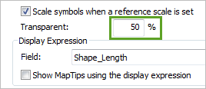

The higher the percentage, the more transparent the layer will be.

1. Click **OK**.

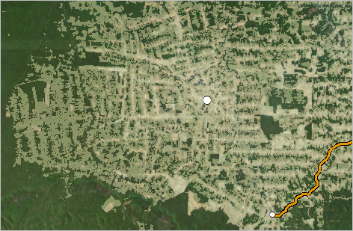

##### Tip:

If you have difficulty seeing the basemap through the transparent layer, you can also turn the **Deforested Area** layer on and off to compare.

You can see where visible deforestation overlaps with areas in the Deforested Area layer. However, some parts of the layer do not seem to coincide with deforestation visible on the basemap, especially areas close to untouched rainforest. Deforestation is a constantly changing process and the basemap may not have been updated to show its most recent occurrences.

1. On the ArcMap main menu, click **Bookmarks** and click **Rondonia**.
2. In the **Catalog** window, add the **Protected_Forests** layer to the **Table Of Contents**, below the **Roads** layer.

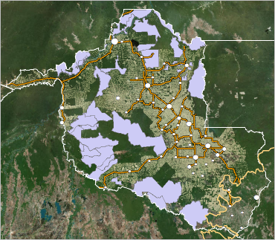

The Protected Forests layer covers the layers under it. You'll change the symbology and make it transparent.

1. In the **Table Of Contents**, click the symbol for the **Protected Forests** layer. In the **Symbol Selector**, scroll through the list of symbols and click the **Pink** symbol.

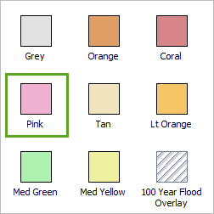

1. Click **OK**. Open the **Layer Properties** dialog box of the **Protected Forests** layer.
2. Change the transparency to 60 percent and click **OK**.

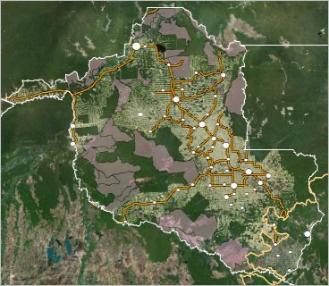

The protected areas seem to be an effective deterrent of deforestation. Now that you can see one of the preventative measures against deforestation, you'll investigate its causes. In the previous lesson, you turned off the Roads layer because the dense road network obscured other layers on your map. Now, you'll take a closer look at those roads to see how they relate to deforestation.

1. In the **Table Of Contents**, check the **Roads** layer to turn it on.
2. Zoom back to the area in the northwest part of the state.

##### Tip:

If you have not navigated anywhere else or closed ArcMap since the last time you zoomed in, you can use the **Go Back To Previous Extent** button on the **Tools** toolbar.

1. Pan and zoom around the map, paying attention to the distribution of roads and deforestation.

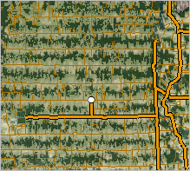

There is a strong relationship between roads and deforestation. In fact, 95 percent of deforestation in the Amazon rainforest occurs within 5.5 kilometers of a road. Roads allow access to the otherwise impenetrable rainforest and facilitate the transportation of lumber. Unlike official roads, which connect cities, unofficial roads access deeper areas of the rainforest and connect rural properties.

Your goal is to estimate how much deforestation a proposed road would cause if its construction were allowed. To make this estimate, you'll first find how much deforestation is associated with existing roads.

1. Return to the **Rondonia** bookmark.

## Select a sample area to analyze

Before you begin your analysis, you'll select a sample area of the existing road network. The road network is massive, with over 20,000 features. Performing analysis on the entire thing would take a lot of time. Selecting a sample area may affect your results slightly, but not much.

1. In the **Table Of Contents**, turn off all layers except the **Roads** layer and the **Imagery** basemap.

##### Tip:

To quickly turn off all layers, right-click **Layers** at the top of the **Table Of Contents** and choose **Turn All Layers Off**. Then, turn on the Roads layer and the basemap.

To select a sample of the Roads layer, you'll use the Select tool. The Select tool selects features from all selectable layers. Turning off the other layers makes them unable to be selected, ensuring that only features in the Roads layer will be selected. The basemap has no features, so it has nothing to select.

1. On the **Tools** toolbar, click the **Select Features** tool.

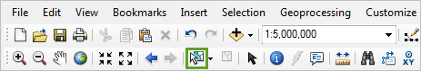

##### Note:

If you click the arrow next to the **Select Features** tool, you can choose from several selection methods. Clicking the **Select Features** tool will use the **Select by Rectangle** method by default.

1. On the map, draw a box around the northwest portion of the state.

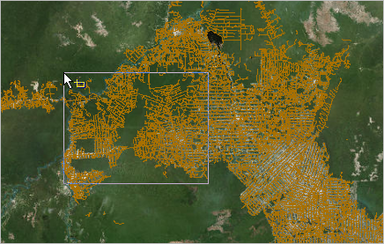

##### Note:

Your selection does not have to match the above image exactly.

The features within the box are selected in the map.

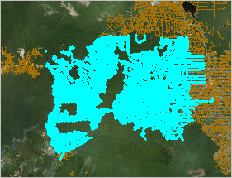

Some roads that extend outside the selection area are selected. If part of a feature is in the selection area, the entire feature is selected.

1. On the ArcMap main menu, click **Selection** and choose **Zoom To Selected Features**.

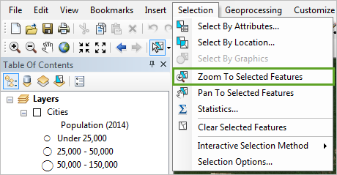

The map zooms to the extent of your selection. Some of the selected roads, particularly on the northern end of your selection, are not near visible deforestation (you can turn on the Deforested Area layer to confirm). Other roads are inside very dense deforestation. Overall, your selection gives a general representation of the roads in this area.

## Find deforestation near existing roads

Next, you'll begin your analysis. To estimate the impact of the proposed road, you'll first determine the impact of existing roads. You'll measure this impact by the percentage of area around roads that is deforested. To find this percentage, you'll create a buffer around your roads selection and compare the buffer's area to the area of deforestation inside the buffer.

1. On the ArcMap main menu, click **Geoprocessing**.

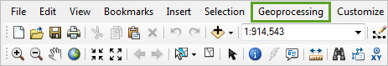

The Geoprocessing menu expands. This menu contains six of the most commonly used geoprocessing tools, as well as options to find and use tools. Geoprocessing tools are operations that manipulate geographic data. Typically, they take an existing dataset as their input and run a process to transform it into a new output.

1. In the **Geoprocessing** menu, click **Buffer**.

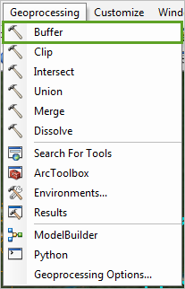

##### Tip:

You also can open the Buffer tool in the Toolbox  or search it from the Search box (see below)

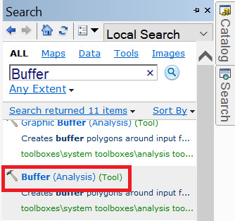

The Buffer dialog box opens. In this dialog box, you'll set your input dataset and a few parameters needed to run the tool. One of those parameters sets the distance of your buffer, or how far away from the input features the buffer area will extend. We set 5.5km as the buffer distance.

##### Tip:

For an explanation of either the tool or a parameter in the tool, click the **Show Help** button in the lower right of the tool window.

1. In the **Buffer** dialog box, for **Input Features**, choose **Roads**.

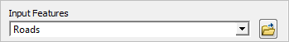

When you choose a layer as your Input Features, only selected features are used as the input. If no features are selected, all features are used.

##### Note:

If you want to use a layer that is not in your **Table Of Contents** as your input, use the **Browse** button and browse to the location of the data.

1. For **Output Feature Class**, confirm that the output location is the **Rondônia**geodatabase.

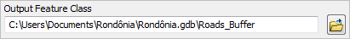

The name of the output feature class is at the end of the text string. In this case, it is Roads_Buffer. You can change the default name by replacing it in the text box, but this name is fine.

1. For **Distance**, in the **Linear unit** text box, type 5500.

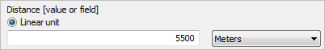

The default measurement unit is meters; 5,500 meters equals 5.5 kilometers. Alternatively, change the measurement unit to kilometers and type 5.5 in the box.

1. At the bottom of the **Buffer** dialog box, click **OK**.

The Buffer tool runs. When the process finishes, the result layer is added to the map.

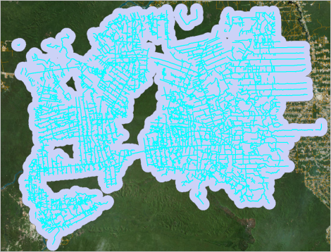

##### Note:

When the output of a geoprocessing tool is added to the map, it has random default symbology. Your symbology may be different than that in the example images.

Next, you'll find how much deforestation falls within this buffer zone.

1. In the **Table Of Contents**, drag the **Roads_Buffer** layer below the **Deforested Area** layer. Turn on the **Deforested Area** layer.
2. On the **Tools** toolbar, click the **Clear Selected Features** button to deselect all features.
3. Compare the Deforested Area and Roads_Buffer layers.

##### Tip:

If the default symbology of the Roads_Buffer layer makes the Deforested Area layer difficult to see, change the symbology of the buffer layer.

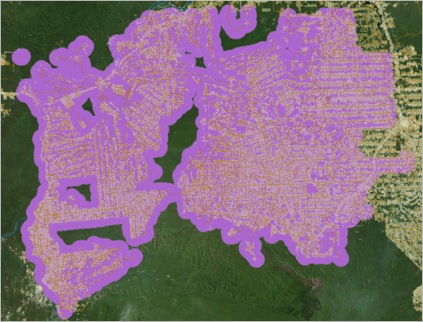

A significant portion of the buffer overlaps with the Deforested Area layer, although not uniformly. The northwestern part of the buffer has many areas that are near roads but have relatively little deforestation.

To calculate the percentage of the buffer that is deforested, you'll need a layer of deforestation within the buffer. You can create this layer using a geoprocessing tool called Clip. The Clip tool clips the extent of one layer to the extent of another.

1. On the ArcMap main menu, click **Geoprocessing** and choose **Clip**.

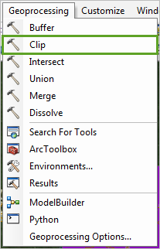

The Clip dialog box opens.

1. For **Input Features**, choose **Deforested Area**.
2. For **Clip Features**, choose **Roads_Buffer**.

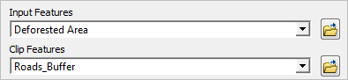

1. For **Output Feature Class**, confirm that the output will be saved to the **Rondônia**geodatabase with the name Deforested_Area_Clip.

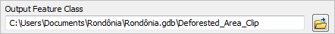

1. Click **OK**.

After the tool finishes, the layer is added to the map.

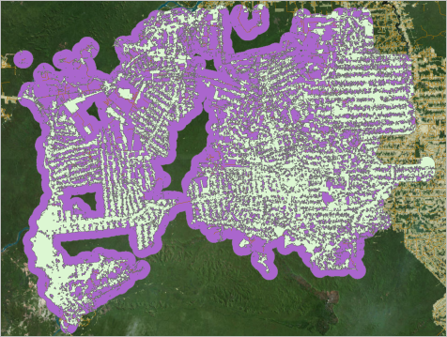

## Calculate the percentage of deforested area near roads

You've created two layers. One shows the area within 5.5 kilometers of the roads in your sample area. The other shows deforestation within that buffer. Your next goal is to calculate the percentage of the buffer that is deforested. To find the percentage, you'll calculate a new attribute field.

1. In the **Table Of Contents**, right-click the **Deforested_Area_Clip** layer and choose **Open Attribute Table**.

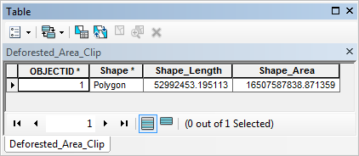

The layer has two fields of geometry that are automatically created for all polygon feature classes: Shape_Length (perimeter) and Shape_Area.

1. Examine the **Shape_Area** field.

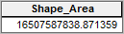

##### Note:

Because the area is based on the sample roads you selected, your area values (and all subsequent values you calculate from them) will probably differ from the example images.

The unit of measurement is not given in the table, but specified in the layer's coordinate system information.

1. Leave the attribute table open and open the **Layer Properties** dialog box of the **Deforested_Area_Clip** layer.
2. On the **Source** tab, under **Data Source**, scroll down to the projection information.

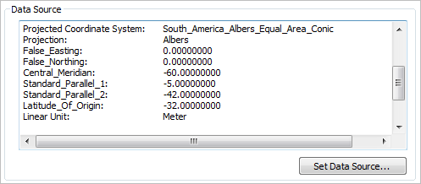

1. Close the **Layer Properties** dialog box and return to the attribute table.
2. Right-click the **Shape_Area** value and choose **Copy**.

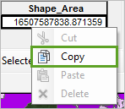

Copying the area will allow you to use it while you look at the Roads_Buffer table.

1. In the **Table of Contents**, right-click the **Roads_Buffer** layer and choose **Open Attribute Table.**

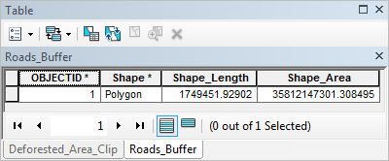

The table opens in a new tab on the table that is already open. Like the Deforested Area Clip layer, the Roads Buffer layer has a Shape_Area attribute. You'll add a new field and use both area values to find the percentage.

1. On the table's toolbar, click the **Table Options** button and choose **Add Field**.

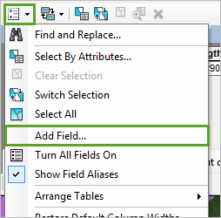

1. In the **Add Field** dialog box, for **Name**, type Percent_Deforested. For **Type**, choose **Double**.

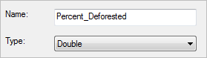

The field type determines what kind of values the field can have. The Double type allows numerals with decimals.

Field names can only have text, numerals, and underscores. You can create a field alias that contains other characters. The field alias is displayed in the table, while the actual name is stored in the data.

1. Under **Field Properties**, click the box next to **Alias** and type Percent Deforested, with no underscore.

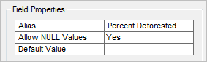

1. Click **OK**.

The Percent Deforested field is added to the end of the attribute table. It has <Null> as its value. <Null> is the default value for new fields and is equivalent to having no value. To add a value, you can edit a table cell directly or create an equation to calculate values.

1. Right-click the **Percent Deforested** field and choose **Field Calculator**.

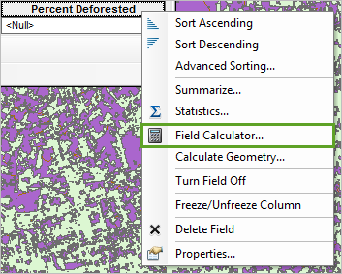

A warning explains that you are about to calculate outside of an edit session.

1. Click **Yes** to ignore the warning.

The Field Calculator opens. The Field Calculator is similar to the Select By Attributes dialog box in that it prompts you to build an expression. It gives you standard mathematical operators and functions as well as existing fields in the attribute table to help build your expression. To find the percentage, you'll divide the area of the Deforested_Area_Clip layer by the area of the Roads_Buffer layer and multiply the result by 100.

1. In the **Field Calculator**, in the text box at the bottom of the window, paste the area value that you copied from the **Deforested_Area_Clip** attribute table.
2. In the list of mathematical operations, click the **division** button.

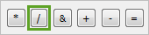

1. Under **Fields**, double-click **Shape_Area**.

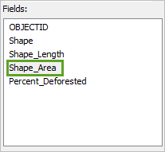

The Shape_Area field is added to the equation after the division symbol. To express the value as a percentage, you'll multiply it by 100.

1. In the list of operations, click the **multiplication** button to add it to the equation.

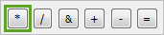

1. In the equation, after the multiplication symbol, type 100.

##### Note:

The initial area value in your expression may be different than the example.

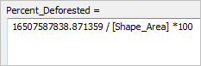

1. At the bottom of the **Field Calculator**, click **OK**.

The Percent Deforested field is calculated. Based on the example area values, the value returned was about 46 percent. Your value may differ, but probably not by more than a couple of percentage points.

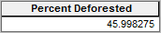

You now know the percentage of land within 5.5 kilometers of roads that is deforested. If a new road were built in this sample area, you could predict that a similar percentage of land within 5.5 kilometers of that road would become deforested.

Now that you have this value, the Deforested_Area_Clip layer is no longer necessary. You'll remove it from your map. You'll keep the Roads_Buffer layer because it has the percentage value in its attributes, but you'll turn off the layer.